**LIT TRAINING**

**Batch Name - SAP ABAP - 25                                                            DAY 8 ASSIGNMENT**

**EMPLOYEE ID – 46247689**

**1. Create a custom Idoc whose fields refers to a custom table.**

**Create a Custom Segment, Idoc type, & Message Type in IDOC.(Tools Used we31,we30).**

**CUSTOM TABLE :**

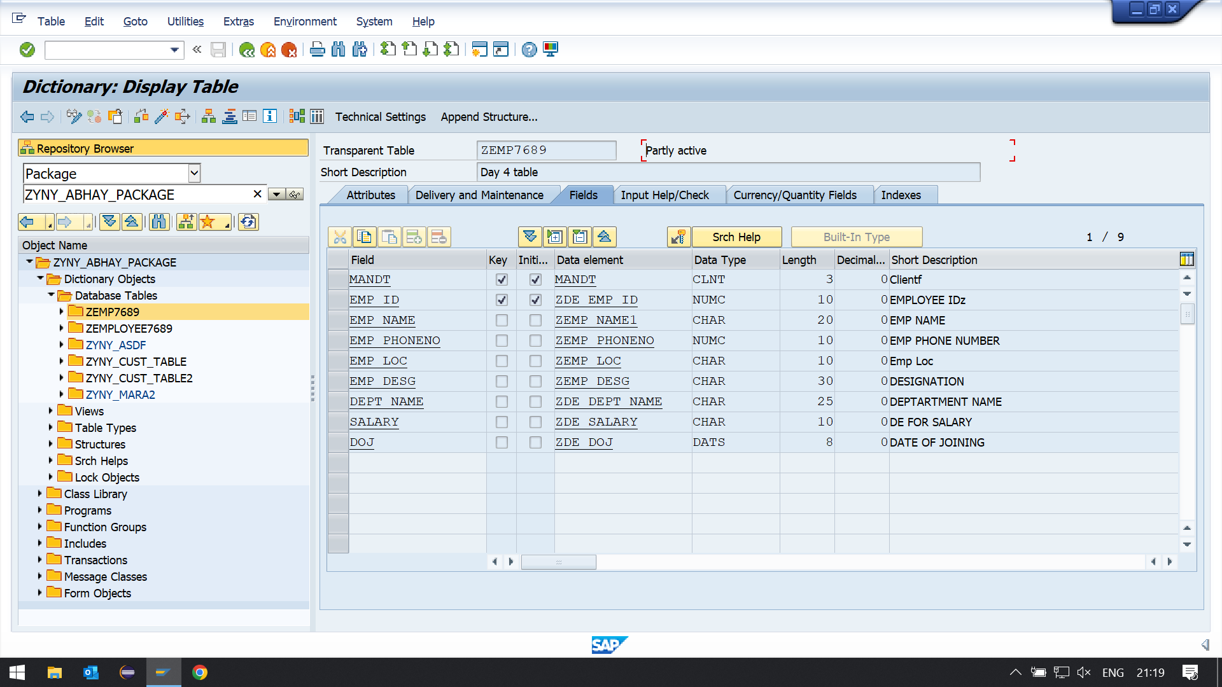

**Creation of IDOC Segment (WE31):**

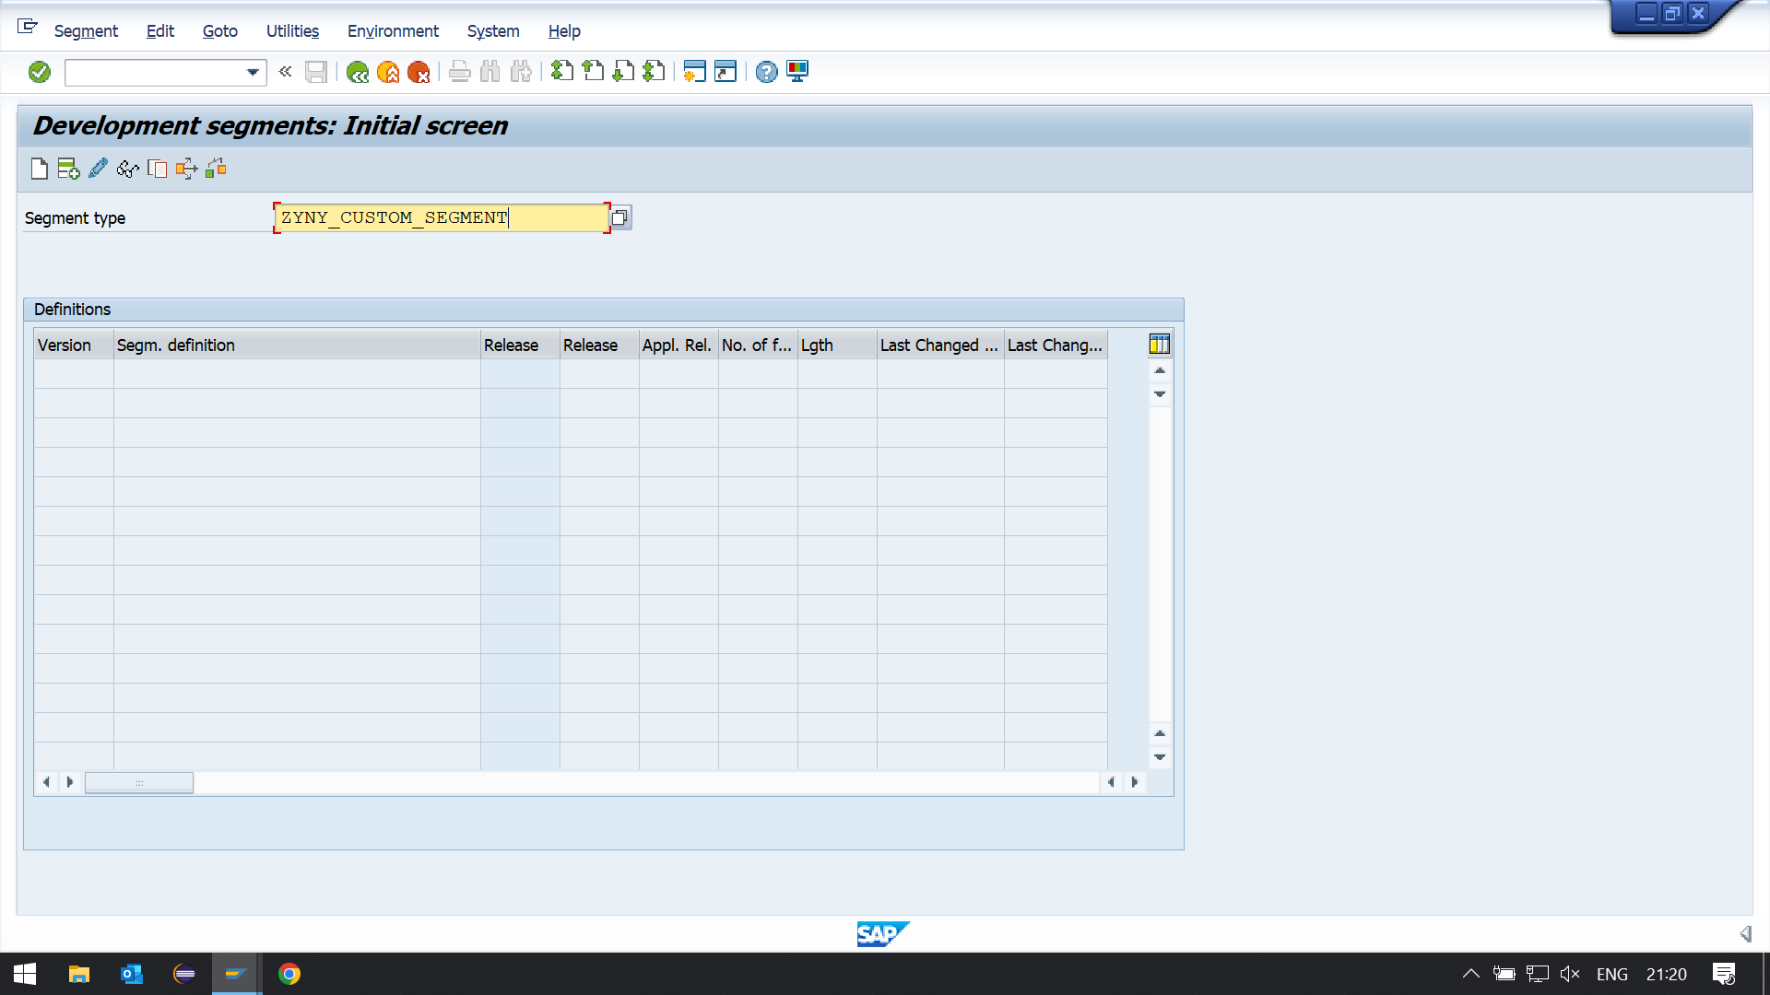

**Enter the names of variables and the data elements**

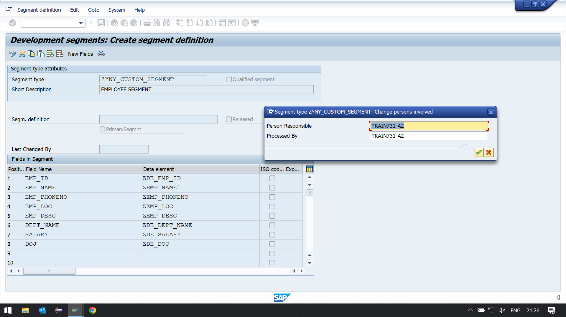

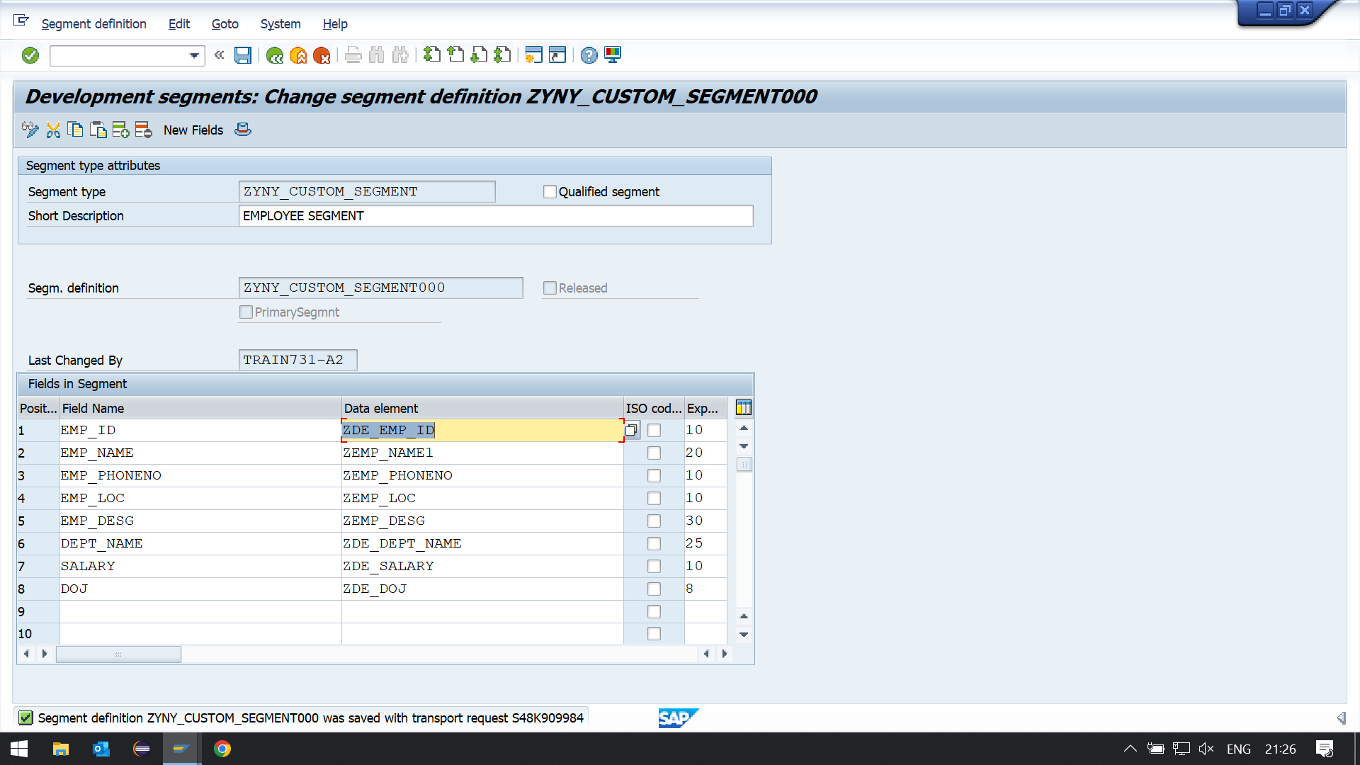

**Creation of IDoc Type (WE30):**

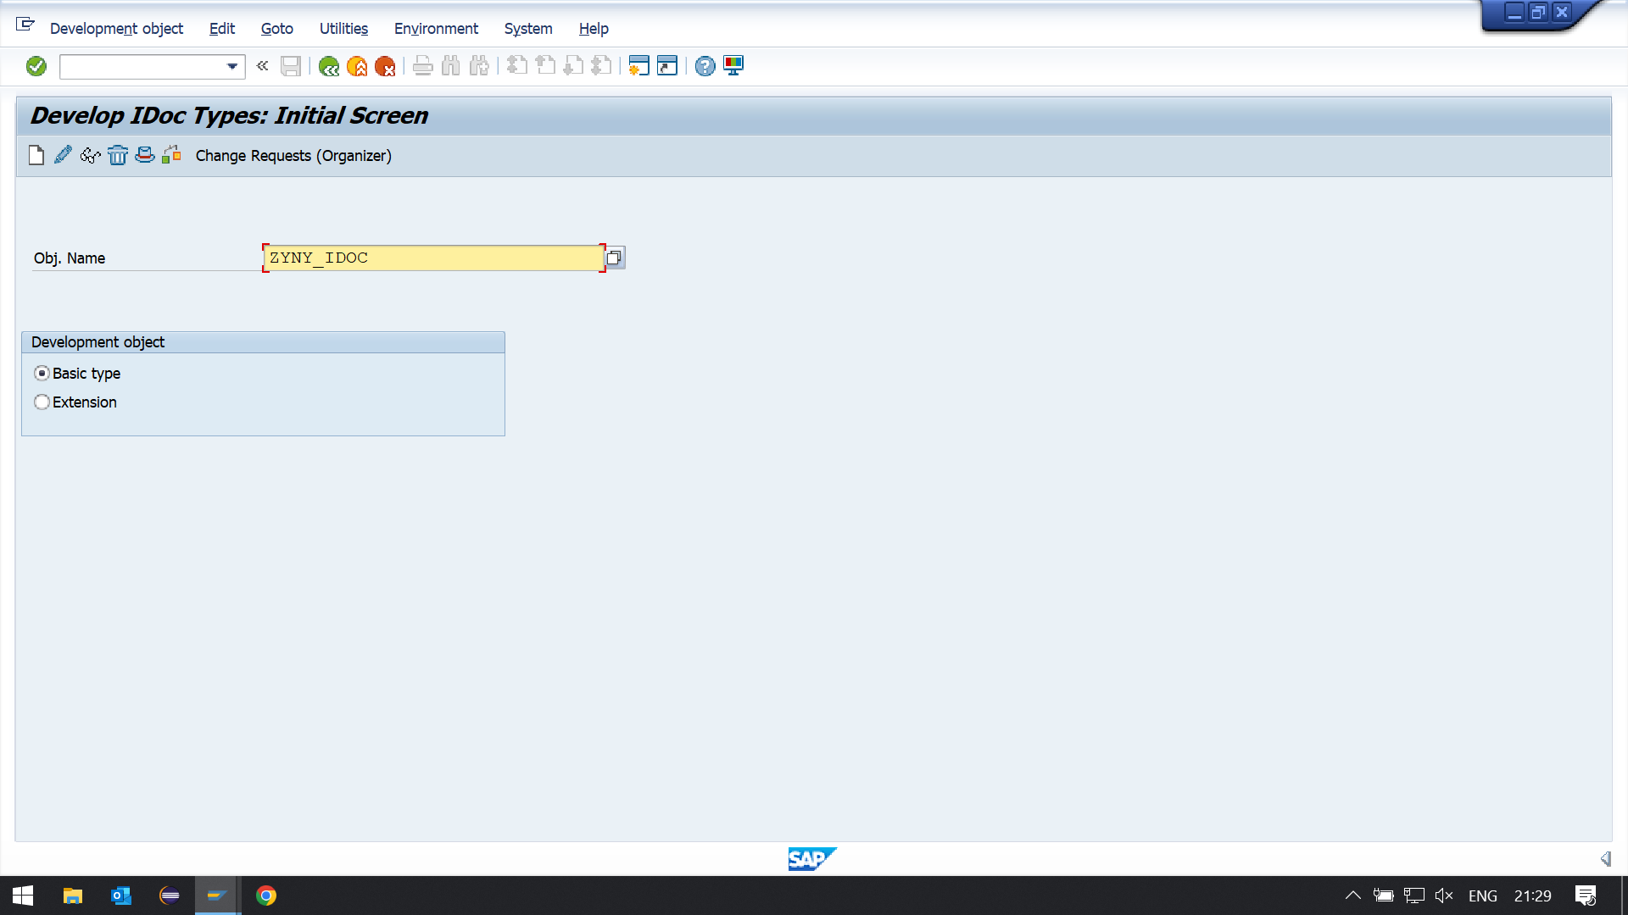

**The system prompts you to enter a type of segment and its attributes.**

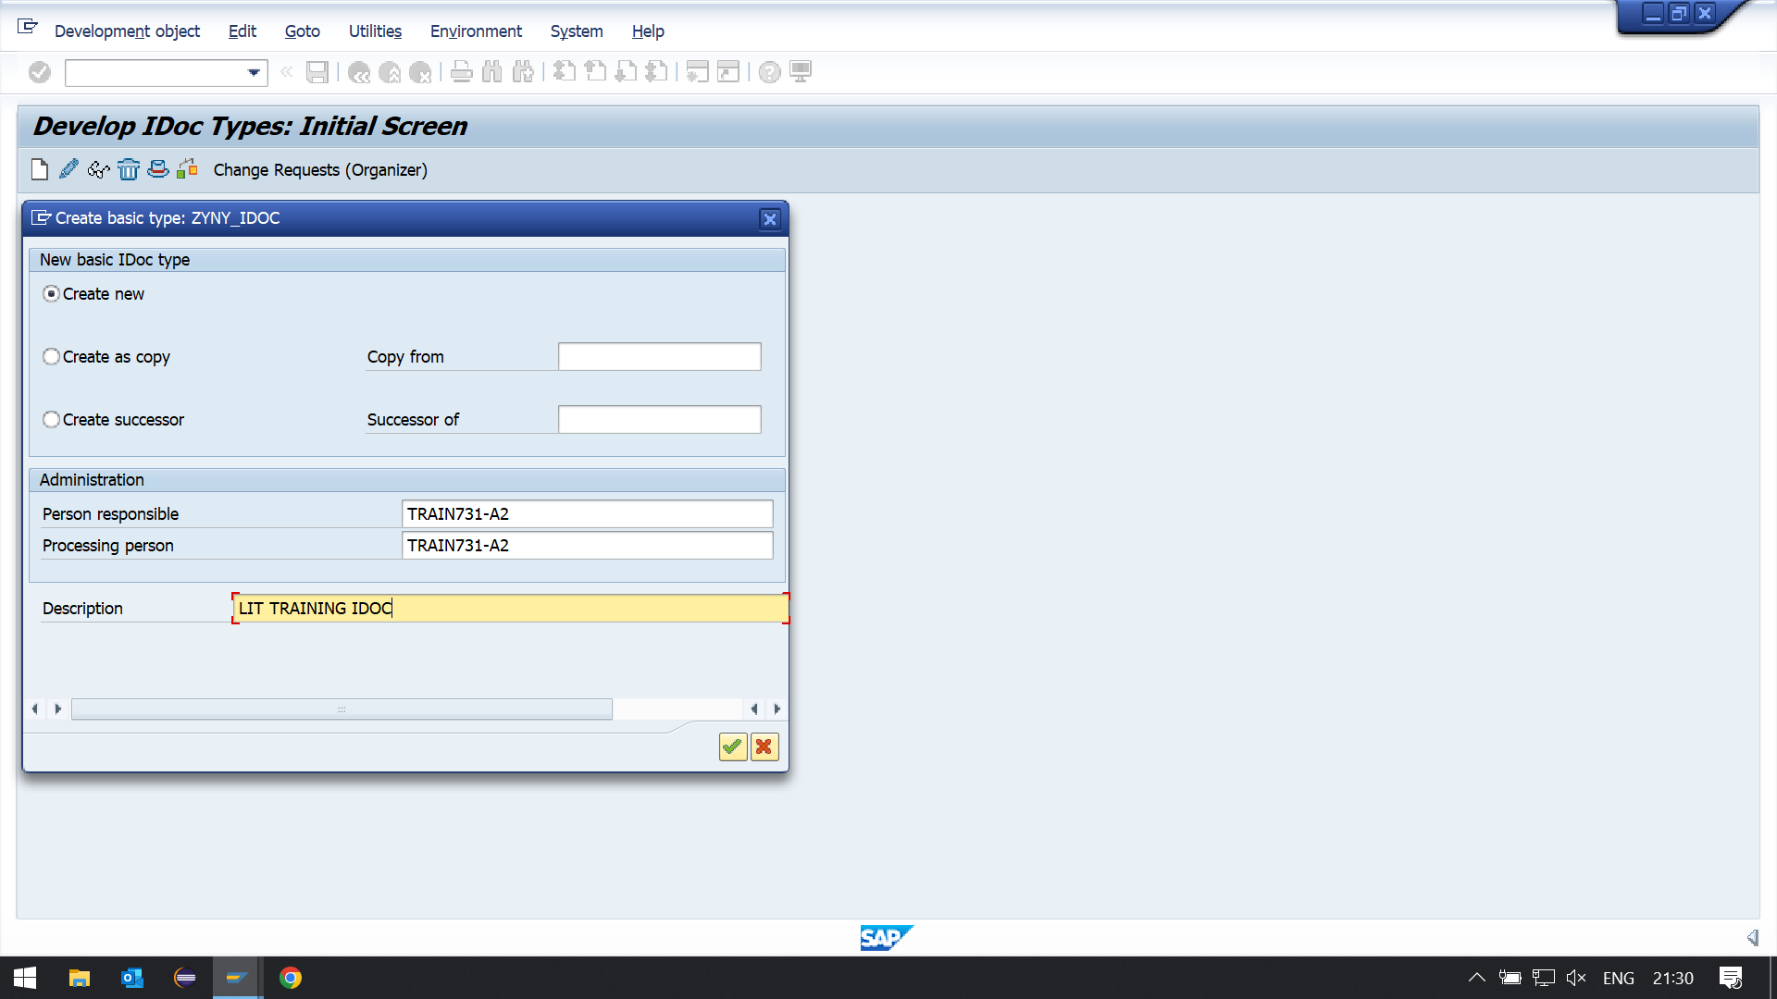

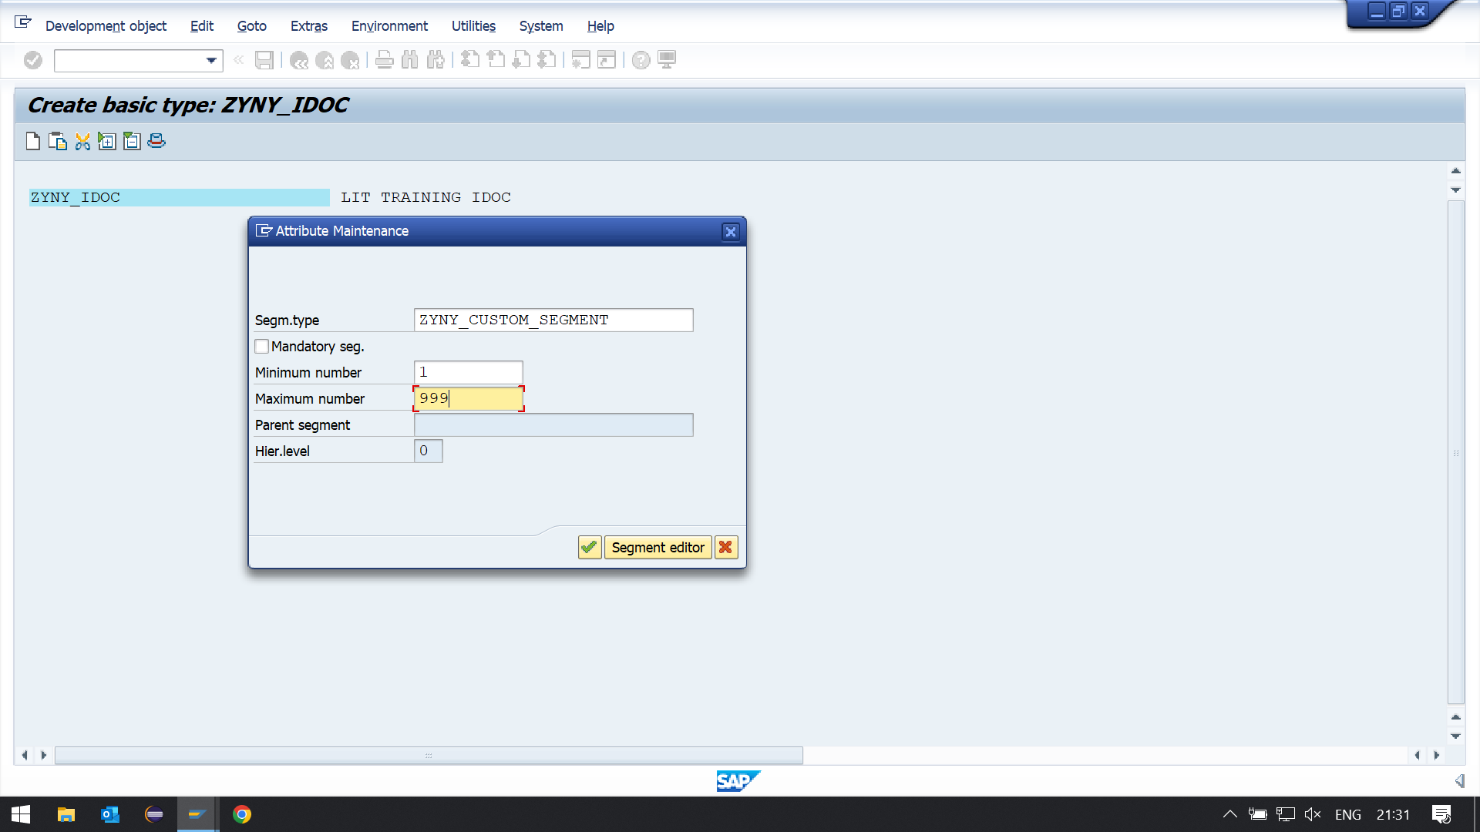

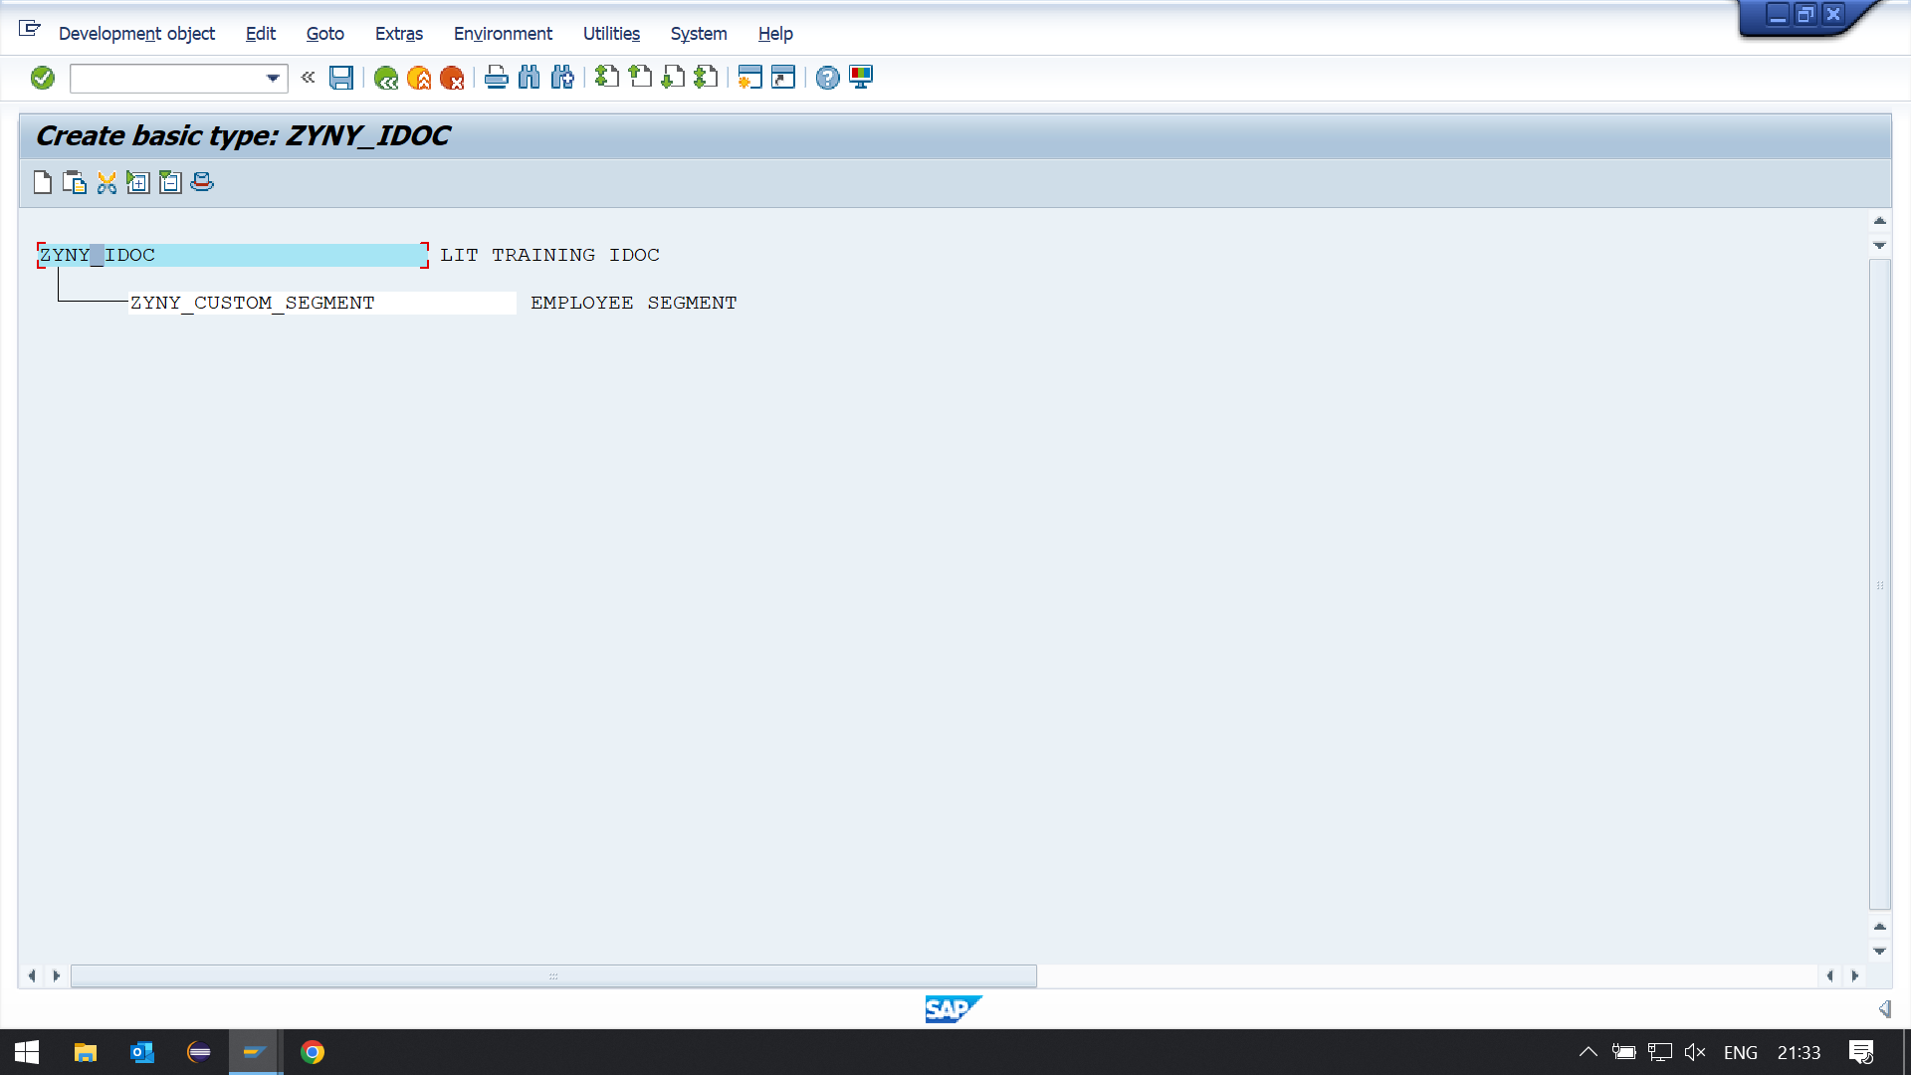

**GO TO WE81**

**SWITCH TO CHANGE**

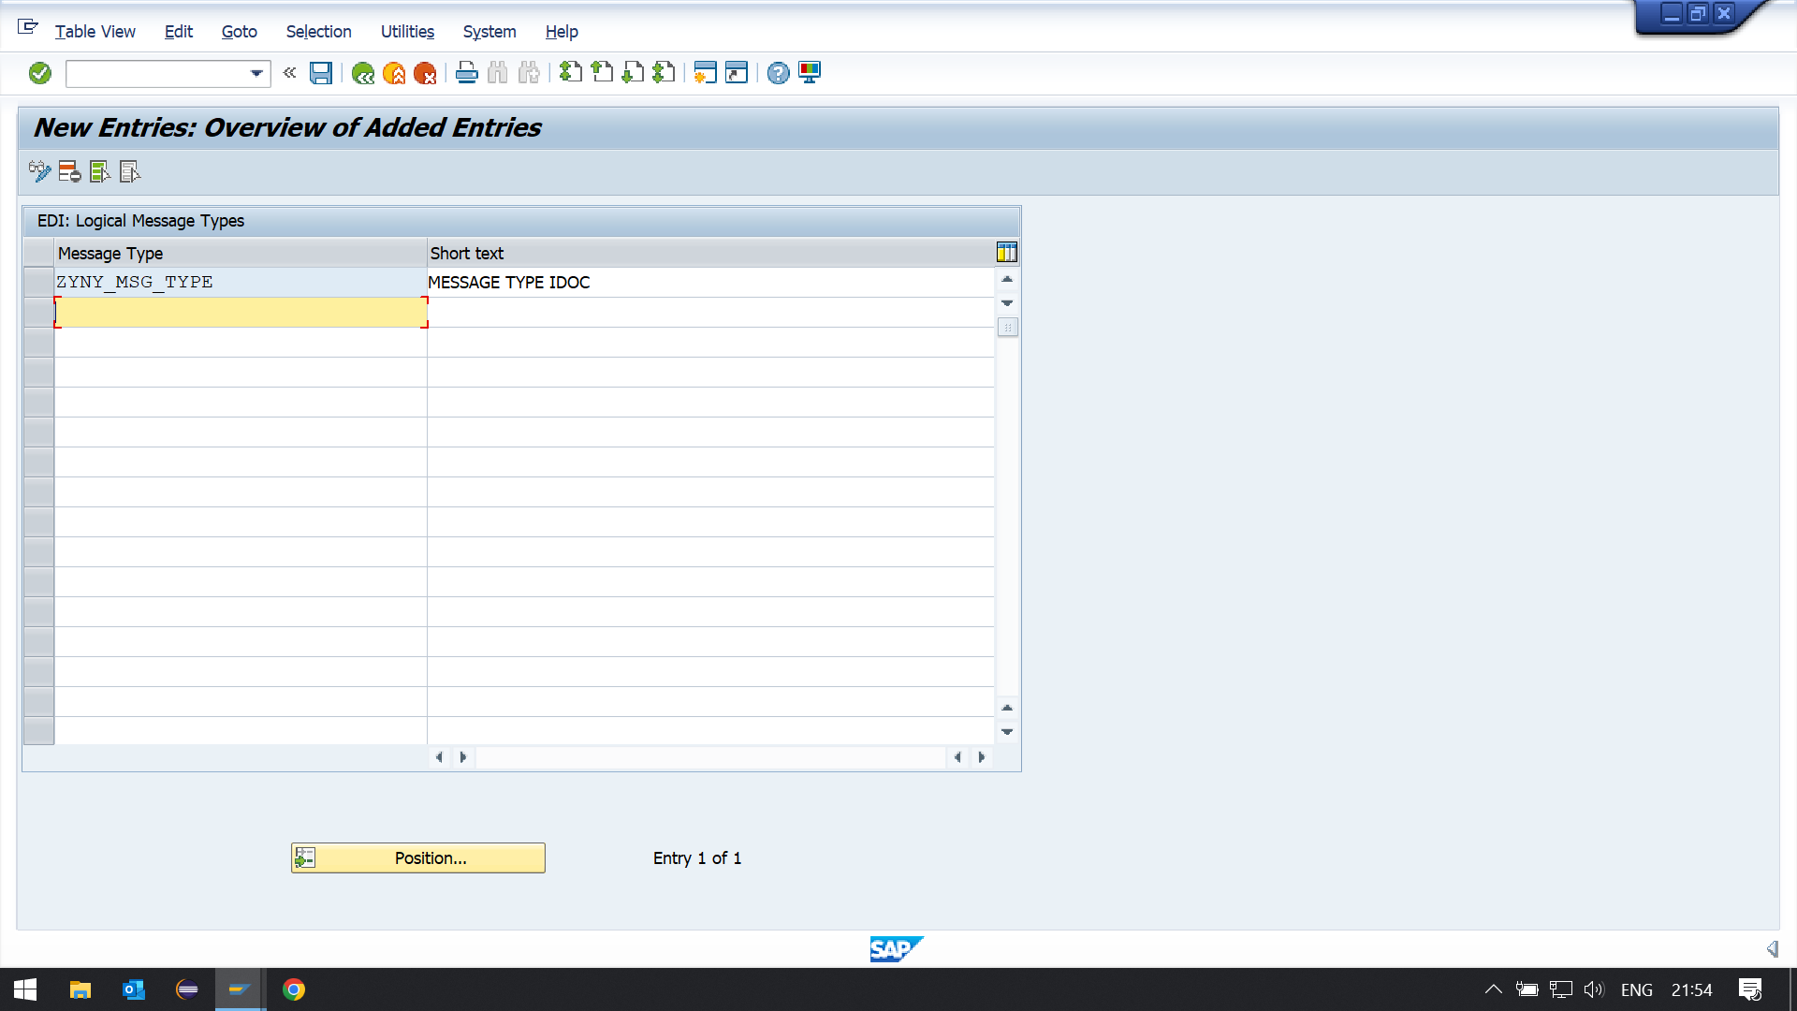

**Assign message type Idoc type in we82.**

**GO TO WE82**

**SWITCH TO CHANGE**

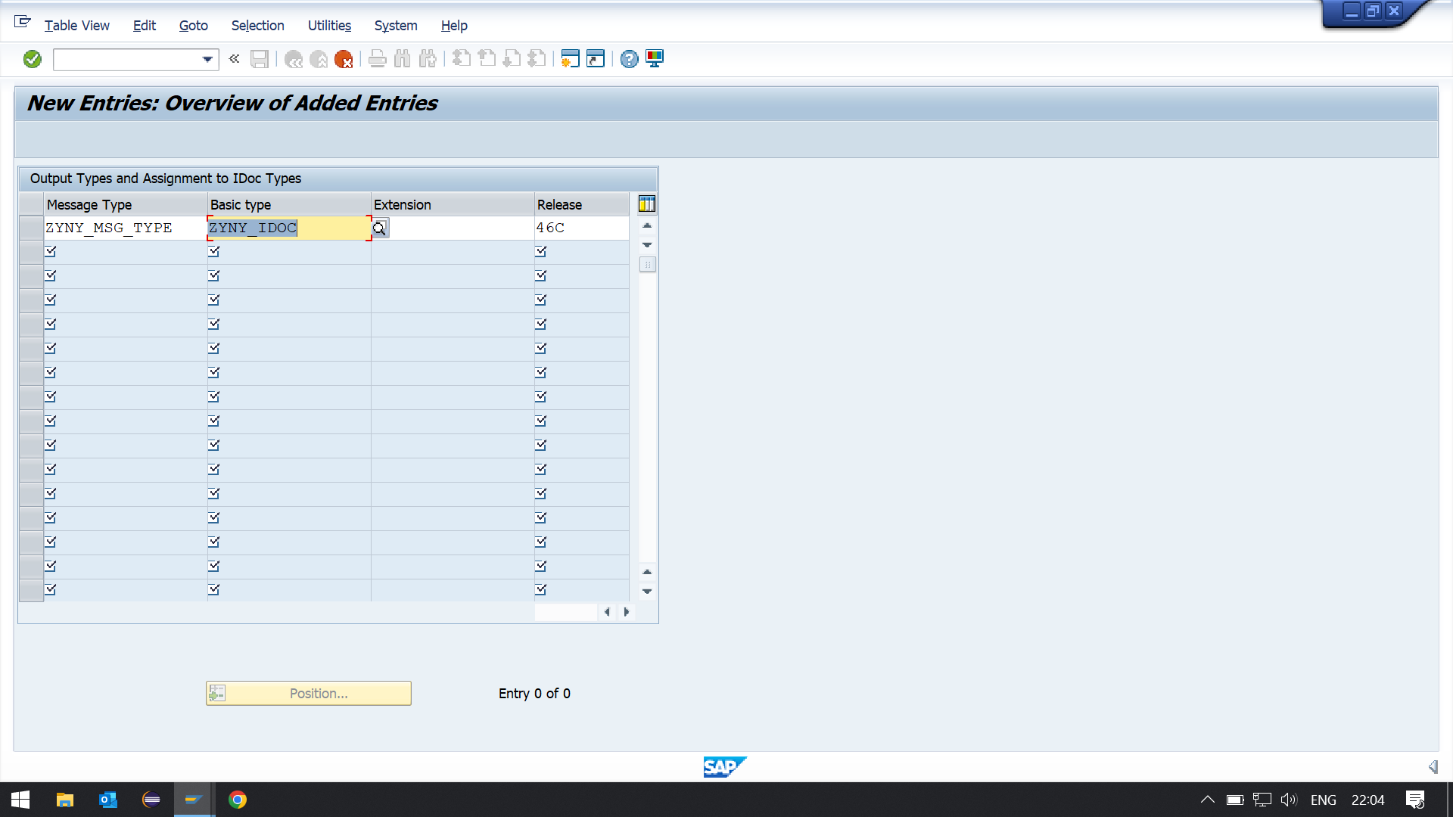

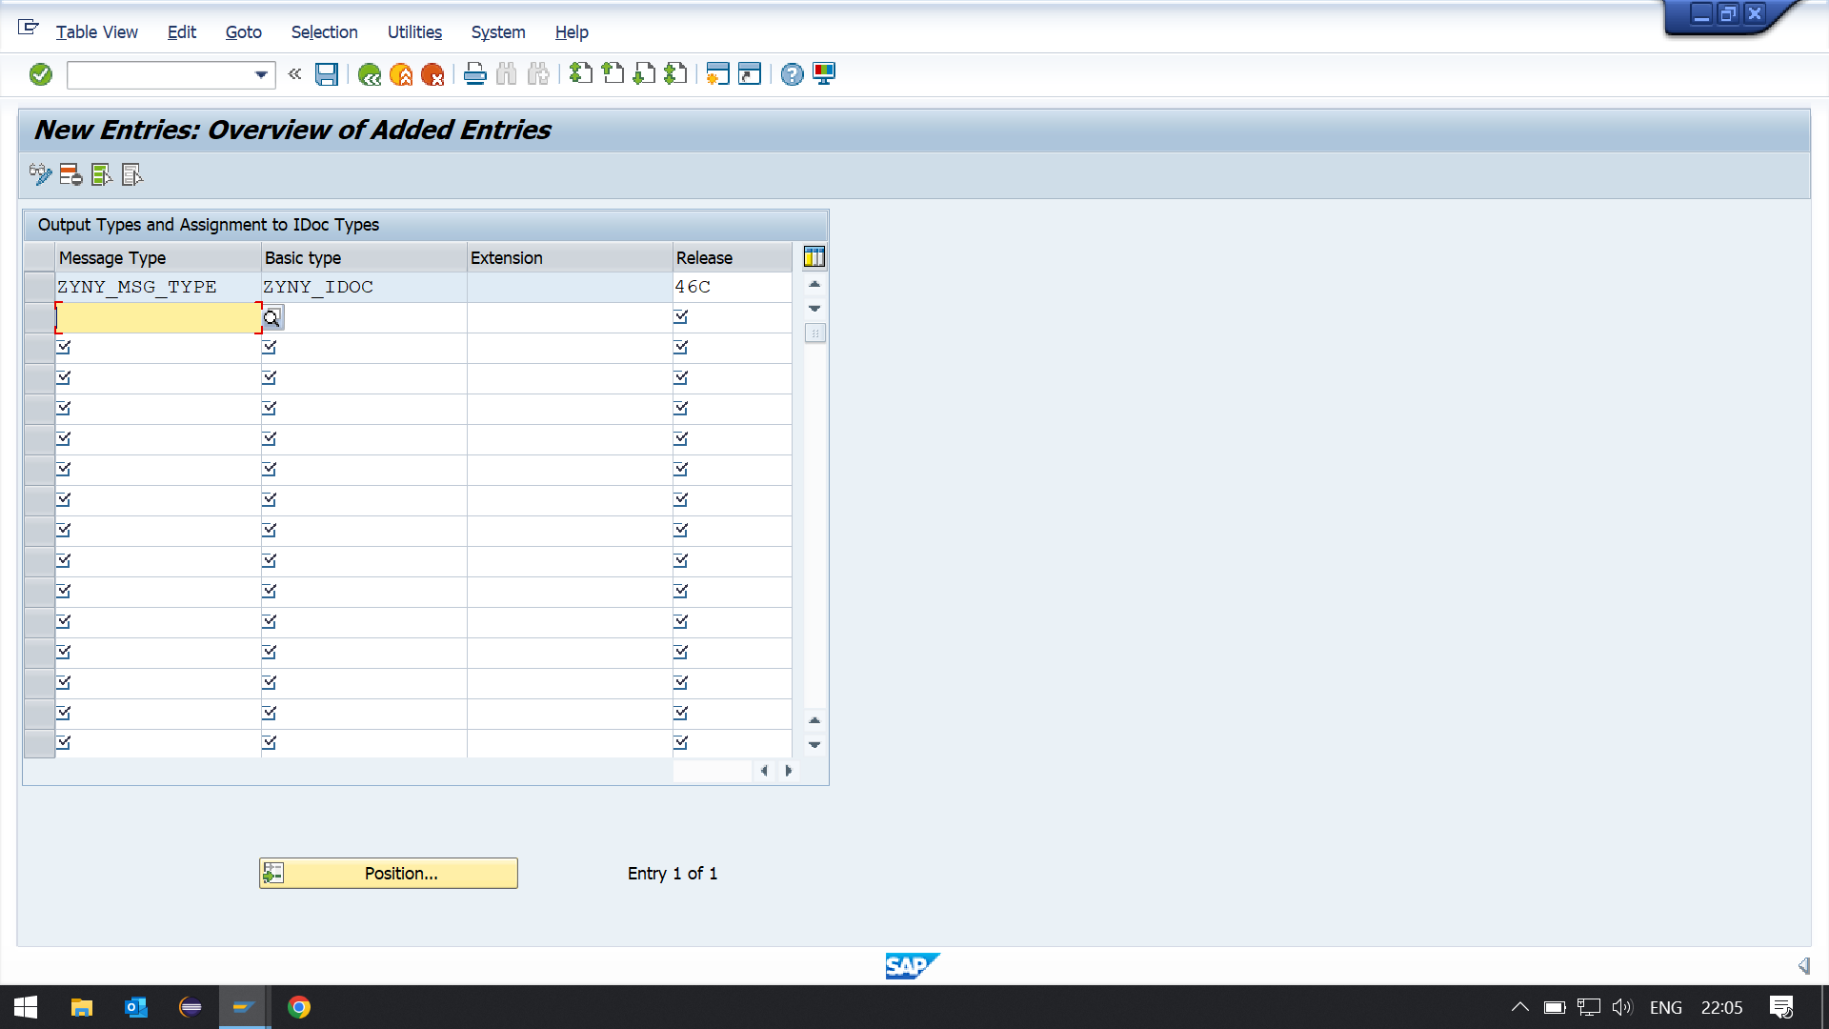

**2. Create an inbound function module to update the data in a custom table.**

**Below input output fields needed:**

**\*"*"Local Interface:**

**\*" IMPORTING**

**\*" REFERENCE(INPUT_METHOD) LIKE BDWFAP_PAR-INPUTMETHD**

**\*" REFERENCE(MASS_PROCESSING) LIKE BDWFAP_PAR-MASS_PROC**

**\*" EXPORTING**

**\*" REFERENCE(WORKFLOW_RESULT) LIKE BDWF_PARAM-RESULT**

**\*" REFERENCE(APPLICATION_VARIABLE) LIKE BDWF_PARAM-APPL_VAR**

**\*" REFERENCE(IN_UPDATE_TASK) LIKE BDWFAP_PAR-UPDATETASK**

**\*" REFERENCE(CALL_TRANSACTION_DONE) LIKE BDWFAP_PAR-CALLTRANS**

**\*" TABLES**

**\*" IDOC_CONTRL STRUCTURE EDIDC**

**\*" IDOC_DATA STRUCTURE EDIDD**

**\*" IDOC_STATUS STRUCTURE BDIDOCSTAT**

**\*" RETURN_VARIABLES STRUCTURE BDWFRETVAR**

**\*" SERIALIZATION_INFO STRUCTURE BDI_SER**

**\*" EXCEPTIONS**

**\*" WRONG_FUNCTION_CALLED**

**STEP 1: FUNCTION GROUP CREATION (SE80).**

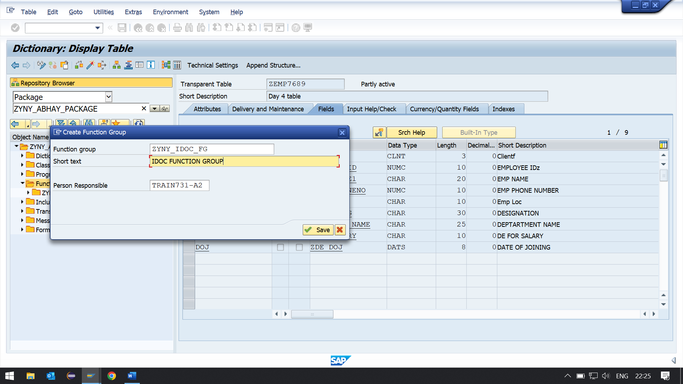

**FUNCTION MODULE(SE37):**

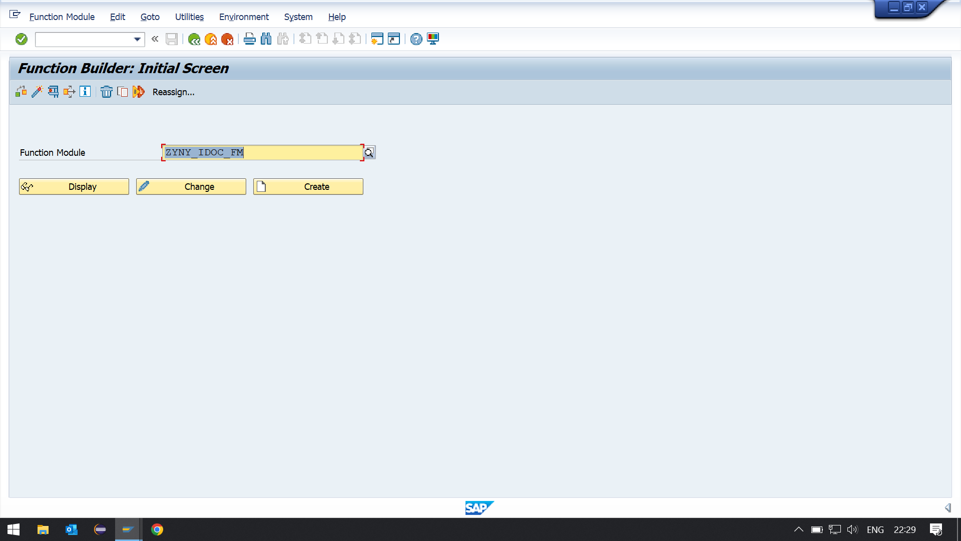

**Function module import, export and table parameters:**

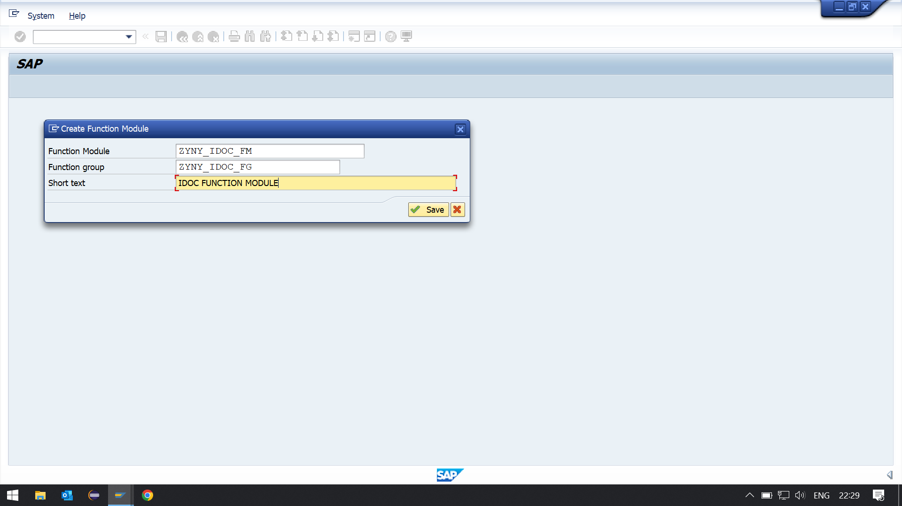

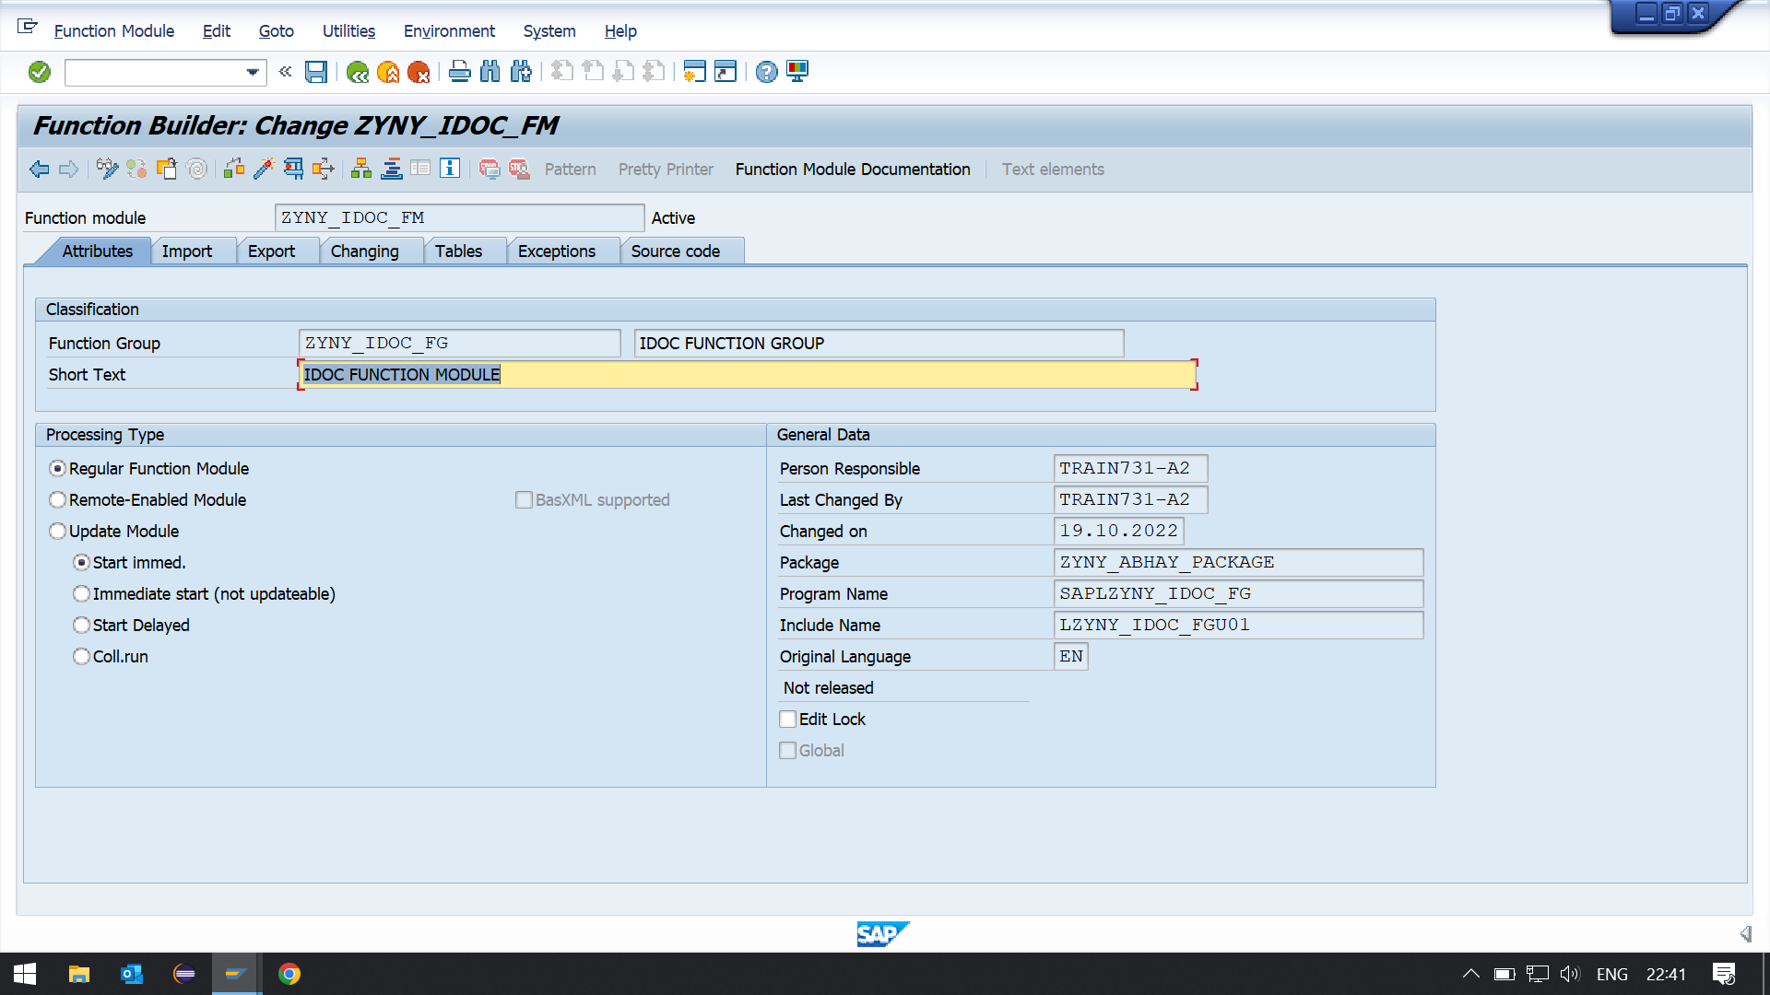

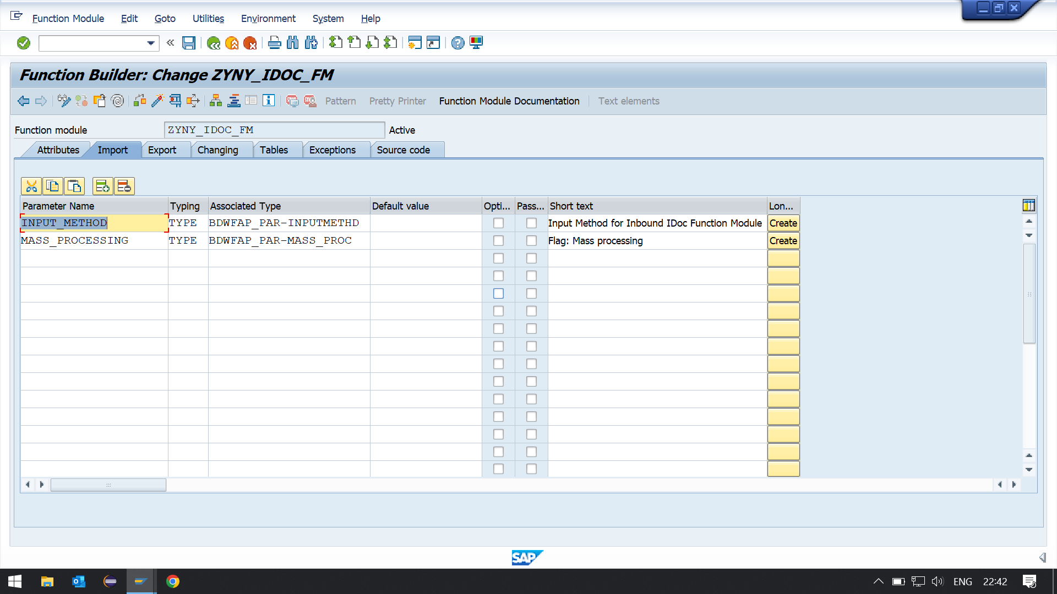

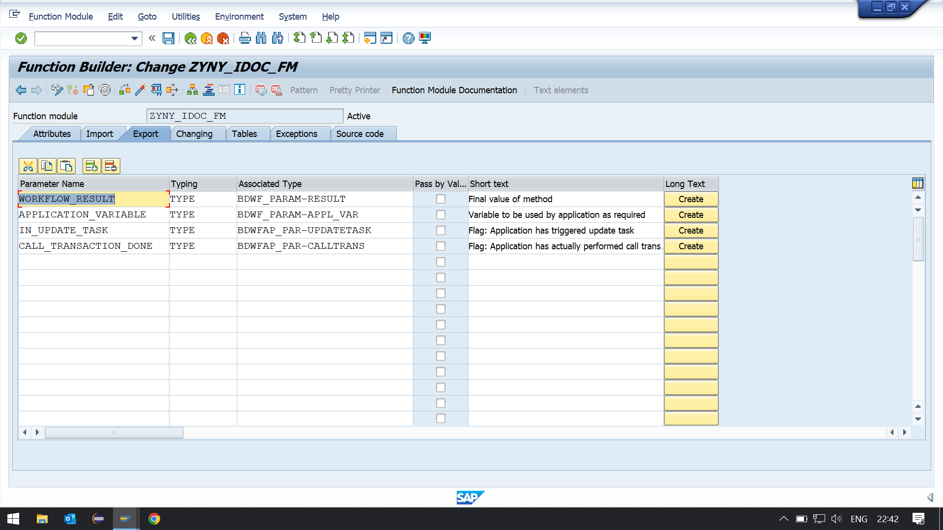

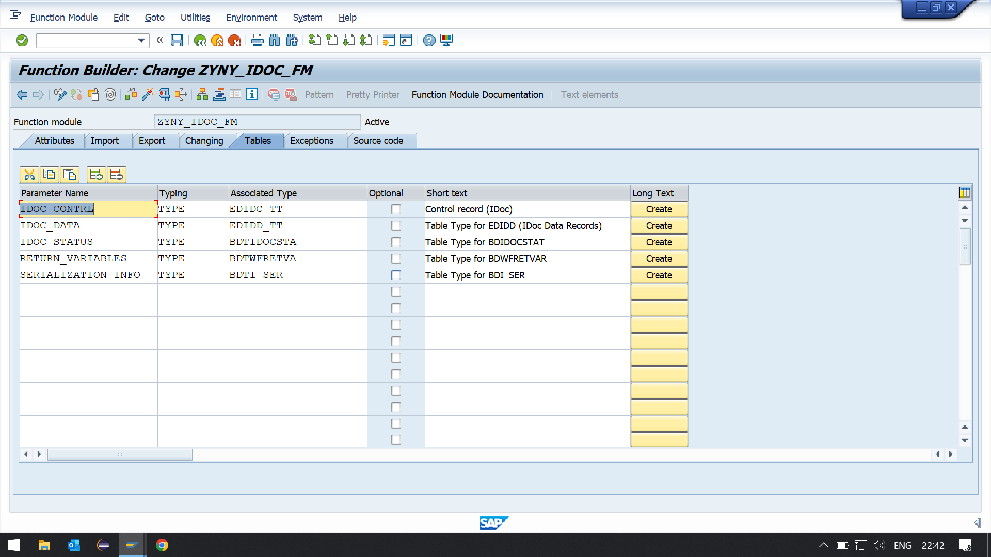

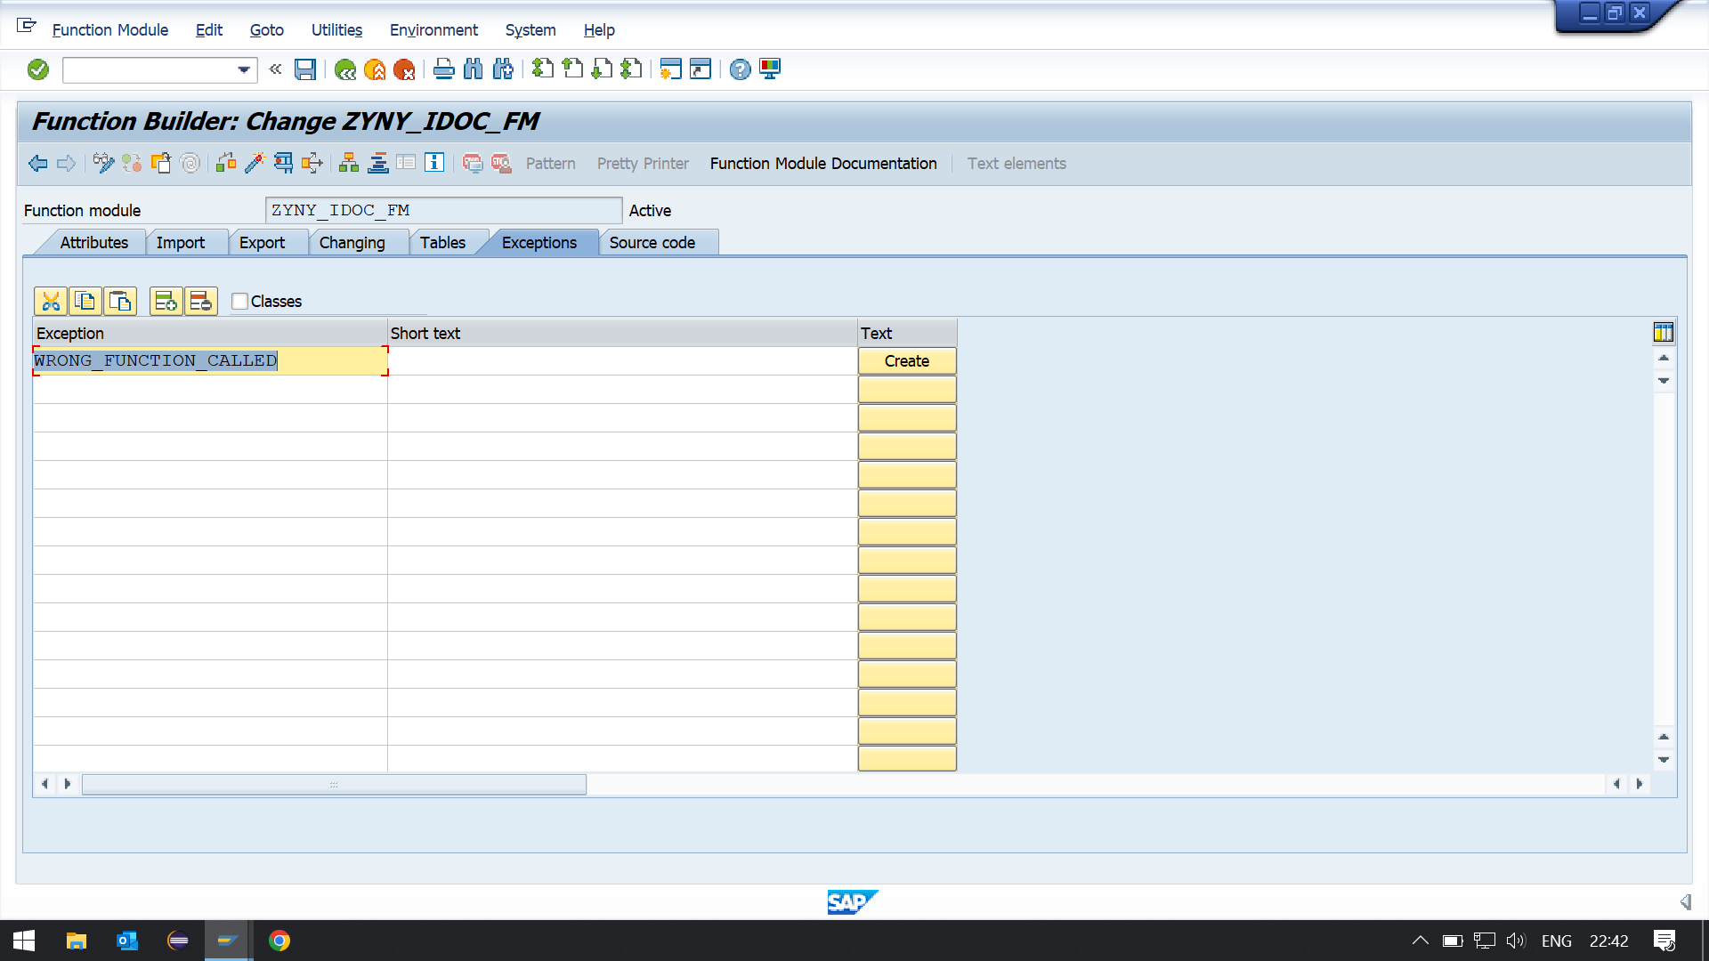

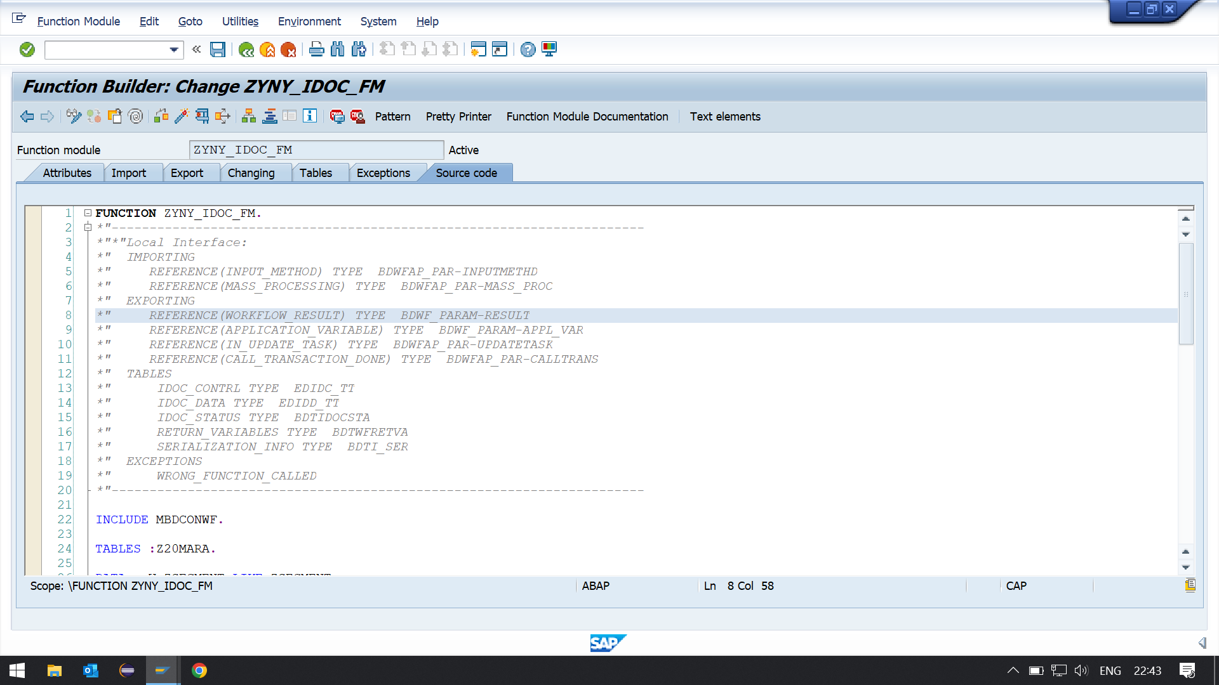

FUNCTION ZYNY_IDOC_FM.  
*\*"----------------------------------------------------------------------*  
*\*"*"Local Interface:*  
*\*"  IMPORTING*  
*\*"     REFERENCE(INPUT_METHOD) TYPE  BDWFAP_PAR-INPUTMETHD*  
*\*"     REFERENCE(MASS_PROCESSING) TYPE  BDWFAP_PAR-MASS_PROC*  
*\*"  EXPORTING*  
*\*"     REFERENCE(WORKFLOW_RESULT) TYPE  BDWF_PARAM-RESULT*  
*\*"     REFERENCE(APPLICATION_VARIABLE) TYPE  BDWF_PARAM-APPL_VAR*  
*\*"     REFERENCE(IN_UPDATE_TASK) TYPE  BDWFAP_PAR-UPDATETASK*  
*\*"     REFERENCE(CALL_TRANSACTION_DONE) TYPE  BDWFAP_PAR-CALLTRANS*  
*\*"  TABLES*  
*\*"      IDOC_CONTRL TYPE  EDIDC_TT*  
*\*"      IDOC_DATA TYPE  EDIDD_TT*  
*\*"      IDOC_STATUS TYPE  BDTIDOCSTA*  
*\*"      RETURN_VARIABLES TYPE  BDTWFRETVA*  
*\*"      SERIALIZATION_INFO TYPE  BDTI_SER*  
*\*"  EXCEPTIONS*  
*\*"      WRONG_FUNCTION_CALLED*  
*\*"----------------------------------------------------------------------*  
  
INCLUDE MBDCONWF.  
  
TABLES :Z20MARA.  
  
DATA : W_ZSEGMENT LIKE ZSEGMENT.  
  
DATA : T_zdemo_material LIKE z20mara OCCURS 0 WITH HEADER LINE.  
WORKFLOW_RESULT = C_WF_RESULT_OK.  
  
LOOP AT IDOC_CONTRL.  
IF IDOC_CONTRL-MESTYP NE 'ZYNY_MSG_TYPE'.  
RAISE WRONG_FUNCTION_CALLED.  
ENDIF.  
  
*\*  Before reading a new entry, clear application buffer*  
LOOP AT IDOC_DATA WHERE DOCNUM EQ IDOC_CONTRL-DOCNUM.  
W_ZSEGMENT = IDOC_DATA-SDATA.  
MOVE-CORRESPONDING W_ZSEGMENT TO T_zdemo_material.  
INSERT INTO z20mara VALUES T_zdemo_material.  
ENDLOOP.  
  
UPDATE z20mara FROM T_zdemo_material.  
  
IF SY-SUBRC EQ 0.  
IDOC_STATUS-DOCNUM = IDOC_CONTRL-DOCNUM.  
IDOC_STATUS-STATUS = '53'.  
IDOC_STATUS-MSGTY = 'I'.  
IDOC_STATUS-MSGID = 'YM'.  
IDOC_STATUS-MSGNO = '004'.  
IDOC_STATUS-MSGV1 = T_zdemo_material-MANDT.  
APPEND IDOC_STATUS.  
CLEAR IDOC_STATUS.  
ELSE.  
IDOC_STATUS-DOCNUM = IDOC_CONTRL-DOCNUM.  
IDOC_STATUS-STATUS = '51'.  
IDOC_STATUS-MSGTY = 'E'.  
IDOC_STATUS-MSGID = 'YM'.  
IDOC_STATUS-MSGNO = '005'.  
IDOC_STATUS-MSGV1 = T_zdemo_material-MANDT.  
APPEND IDOC_STATUS.  
CLEAR IDOC_STATUS.  
  
WORKFLOW_RESULT = C_WF_RESULT_ERROR.  
RETURN_VARIABLES-WF_PARAM = 'Error_Idocs'.  
RETURN_VARIABLES-DOC_NUMBER = IDOC_CONTRL-DOCNUM.  
APPEND RETURN_VARIABLES.  
CLEAR RETURN_VARIABLES.  
ENDIF.  
ENDLOOP.  
  
ENDFUNCTION.

## ****Assign FM(Function Module) to IDoc Type and Message Type(WE57).****

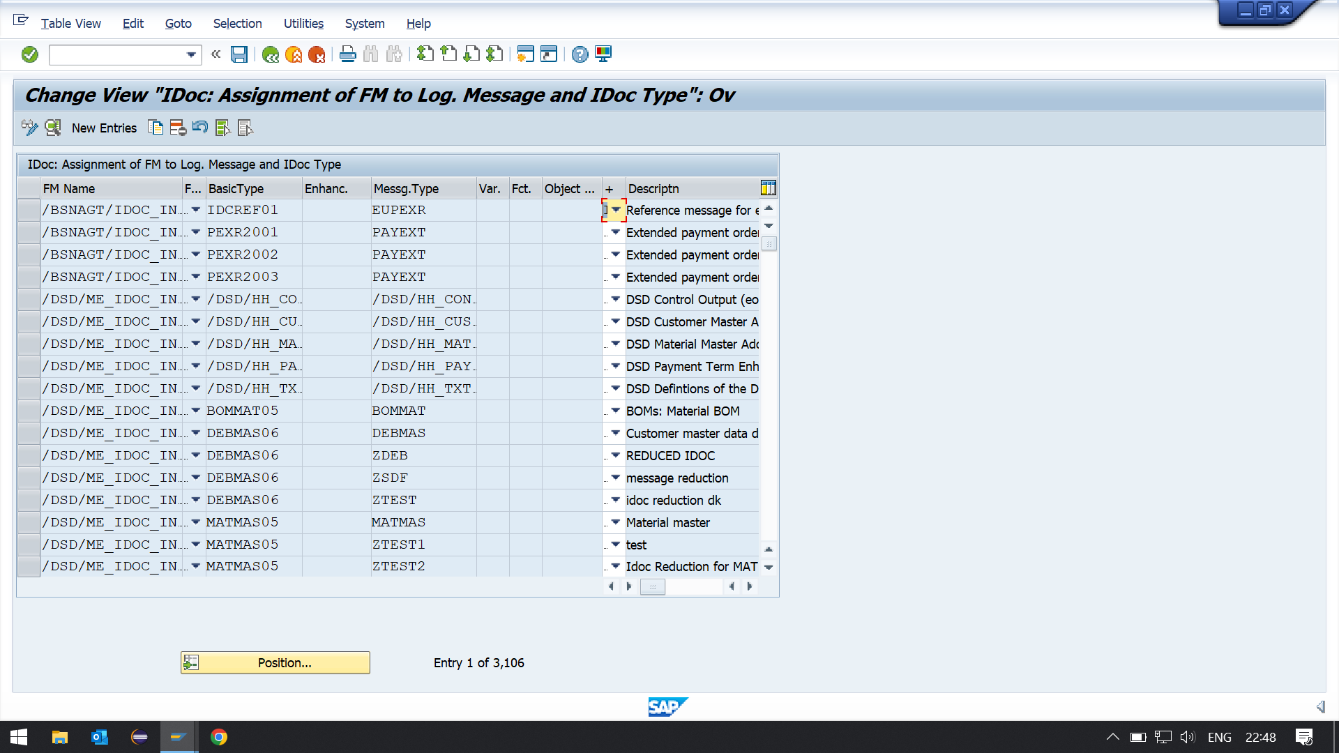

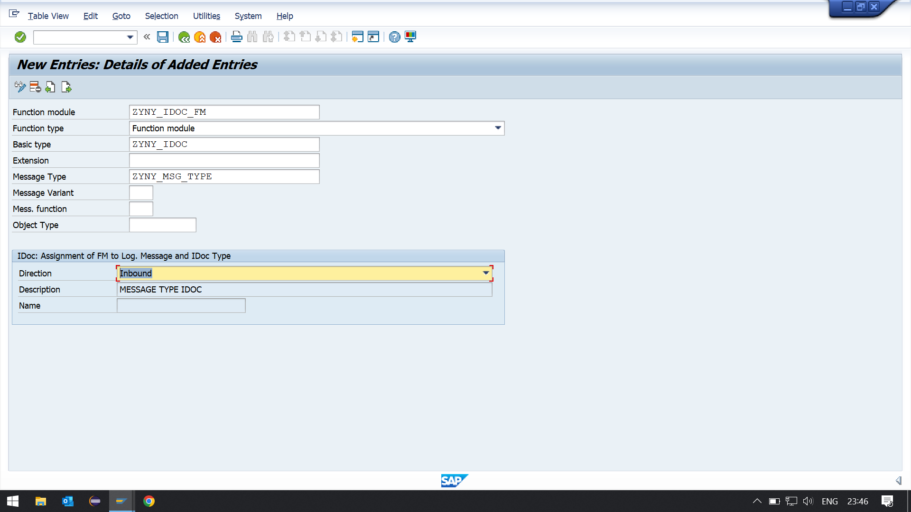

## ****Define Inbound FM Characteristics (BD51):****

* + **Take transaction code BD51**
  + **Click New Entries to create a new type of message**

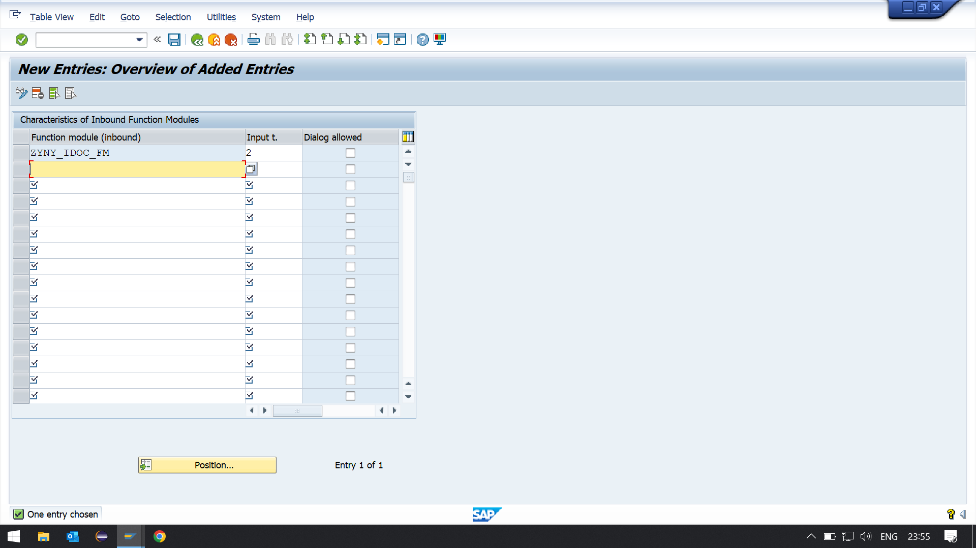

## ****Create Inbound process code (WE42):****

* **Go to the WE42 transaction code**
* **Click the New Entries button to create a new Inbound process code.**
* **Fill in details**
* **Save it and go back there.**

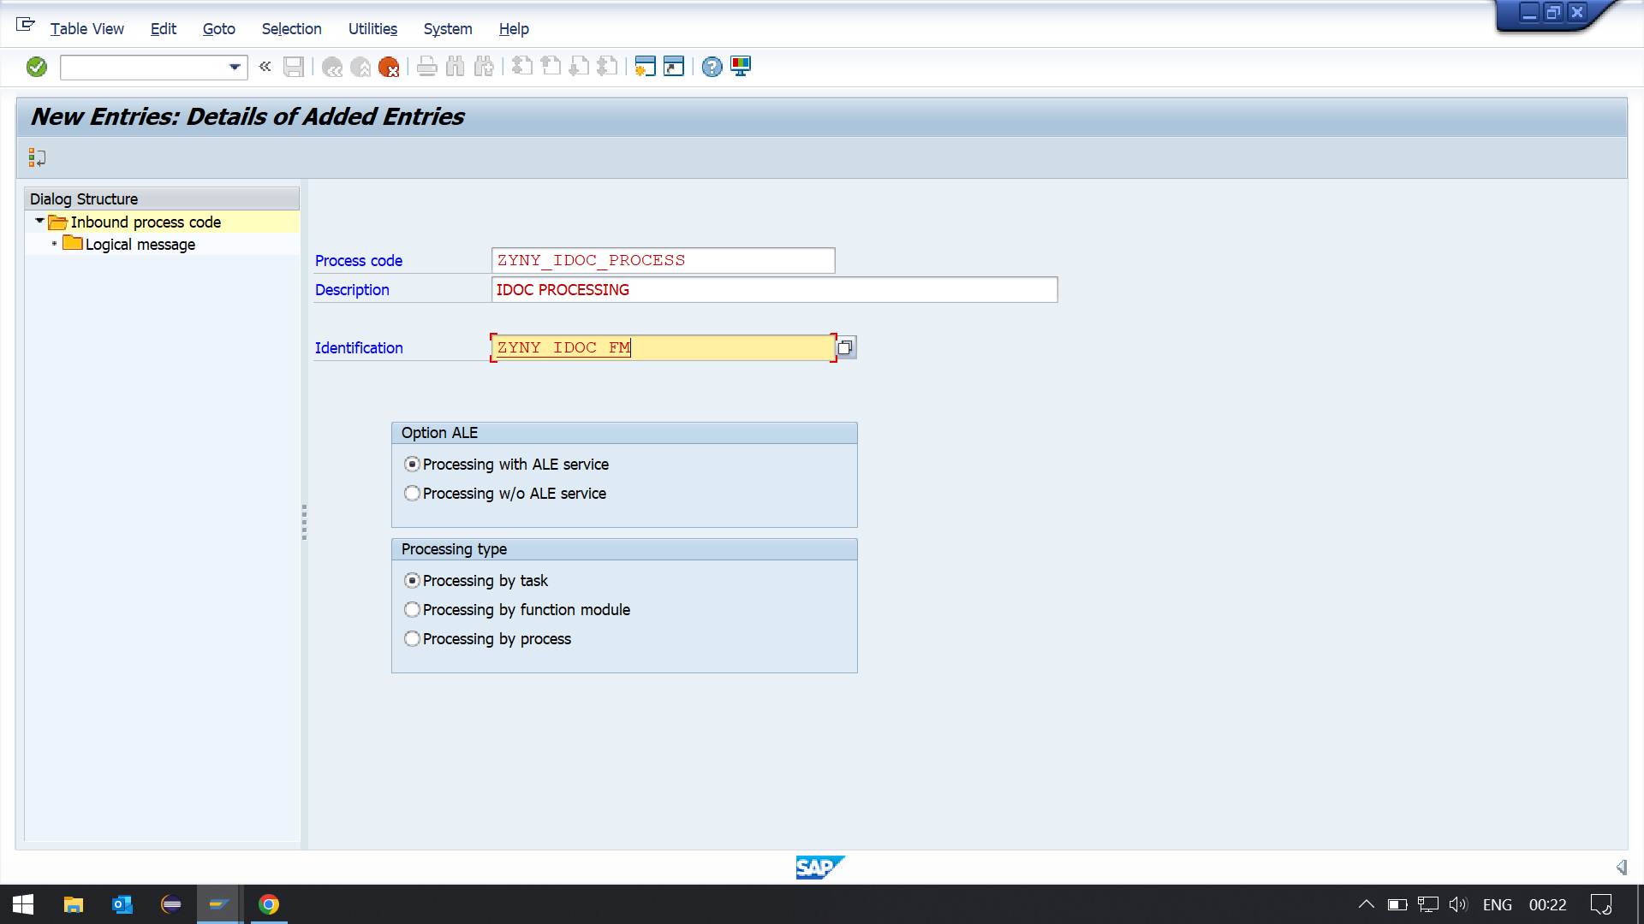

**3. Create a testing Scenario where we can upload data using Standard IDOC.(MATMAS, CREMAS etc)**

**Check in the system after updatation.**